**How to uninstall Piwik PRO old app model connector**

1. Define variables in script: PiwikPRO_Uninstall_AppModelTracker.ps1

Open script in the notepad or another text editor and define the variables:

**$IISWebSiteName** - for example: "piwikpro.piwik.local"  
This is the name of website in IIS which was created for Piwik Tracker provider hosted app. Important: This is not a Sharepoint Site!

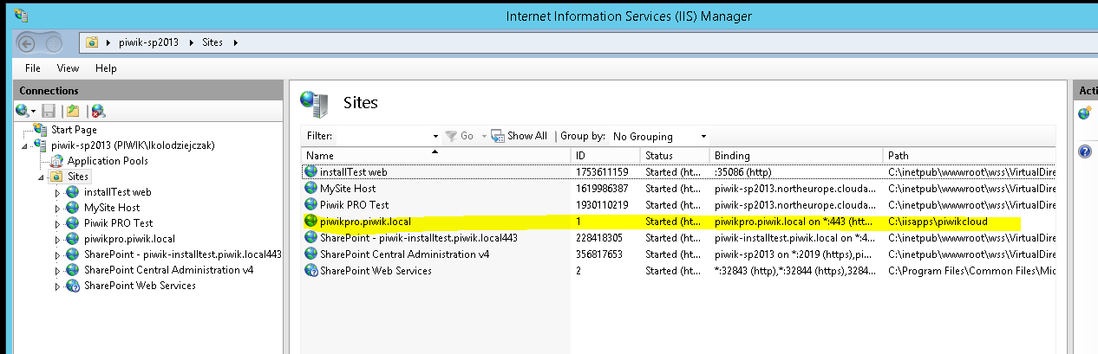

**$IISAppPoolName** - for example: " piwikpro.piwik.local"

This is a name of Application pool in IIS which was created for Piwik Tracker provider hosted app. Important: This is not a Sharepoint Web Application pool!

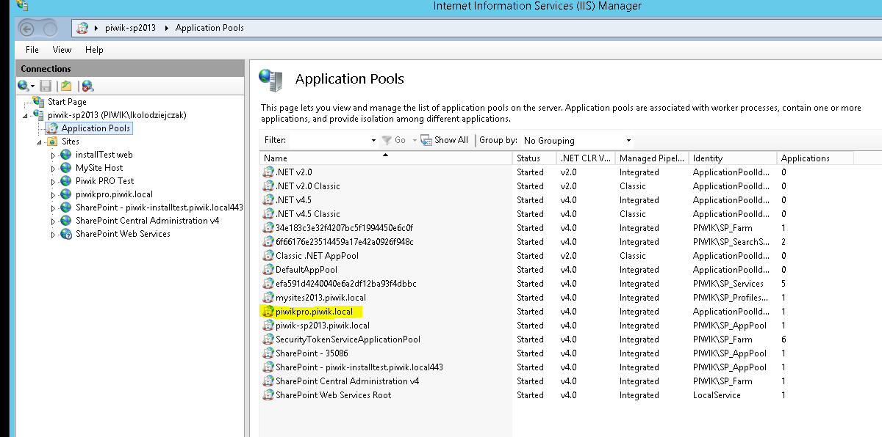

**$WebApplicationTrackerUrl** - for example: <http://piwik-sp2013:35086/>

It is an url to the webapplication which has been installed old Piwik Tracker app model version.

If you filled those 3 variables, Save the file.

1. Run the script

* Run Powershell as administrator



* Navigate to folder with script and execute:

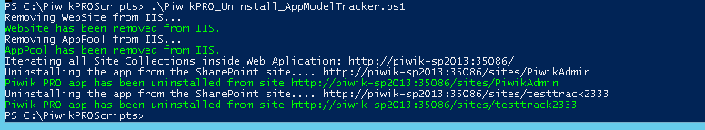

This script removed WebSite and AppPool of old tracker from IIS and Piwik PRO app with custom action.

1. Manual deletion of Piwik PRO app in App Catalog

Go to Central Administration and click Manage App catalog:

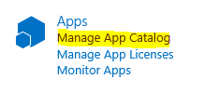

There you will see app catalog sites for specific Web Application, please select the one that you installed Piwik PRO app model tracker and go to the app catalog of it:



From the navigation go to Apps For Sharepoint:

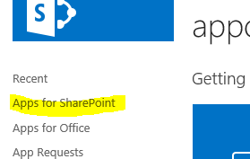

Select Piwik PRO app and click delete:

